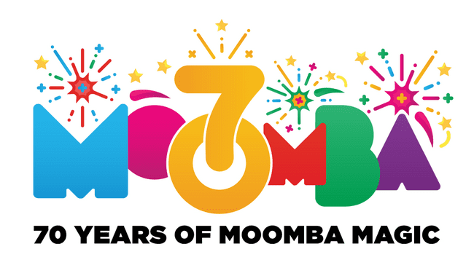

Social Story

_______________________________

My adventure at Moomba

This book belongs to

________________________________

I am going to the city to have fun at Moomba Festival.

There will be lots of people  
and noisy places.

But there will be quieter places too.

There will be lots of fun of things   
to see and do.

I will see people in costumes.

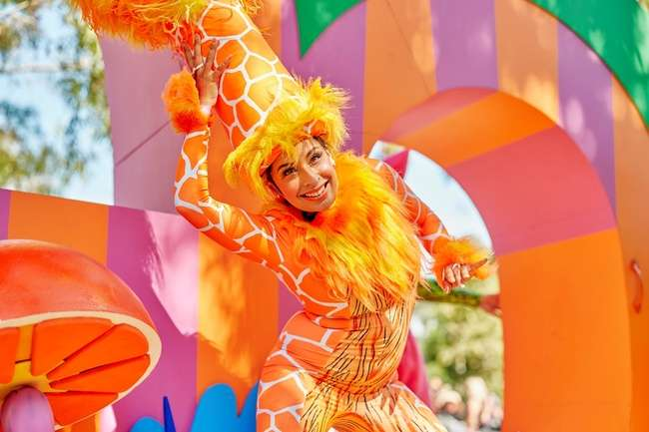  
  
I can do art and craft.

I can build things.

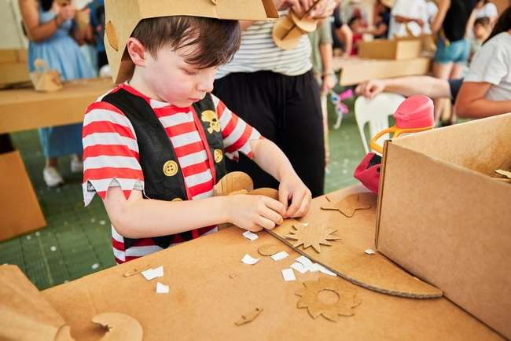

I can have my face painted.  
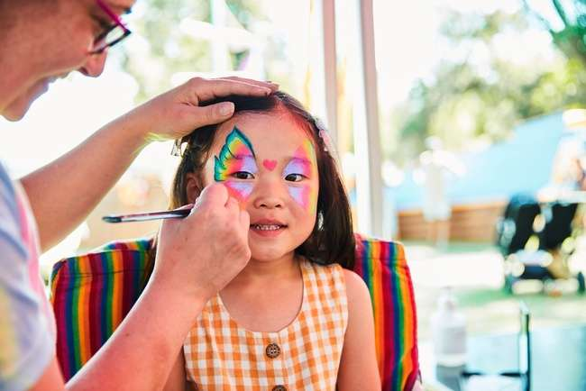

I can sing and dance to music.

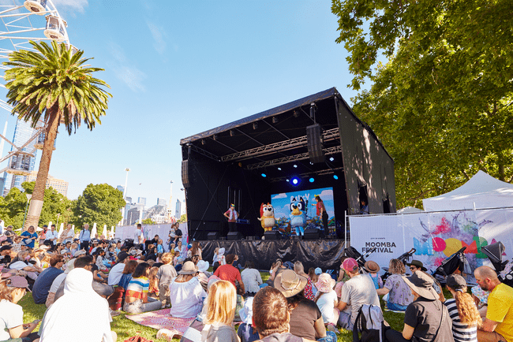

There will be yummy food to buy…

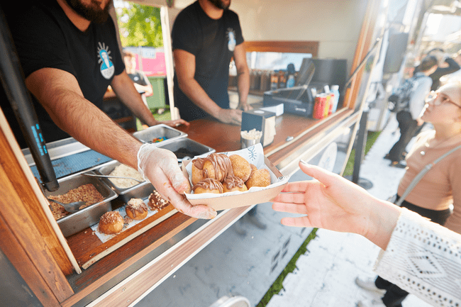  
  
  
  
  
  
  
  
  
  
Or I can eat food I bring from home.

If I need the toilet, I will let my family know and they will help me.

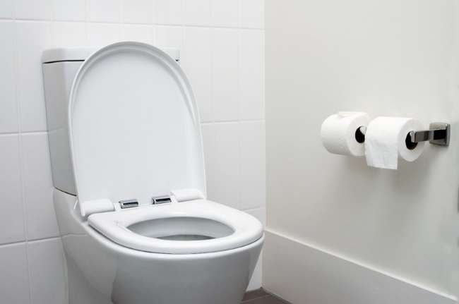

If I get tired or anxious I can relax in a Quiet Zone in the Traveller’s Aid Marquee

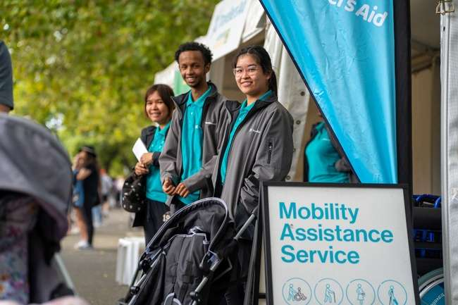

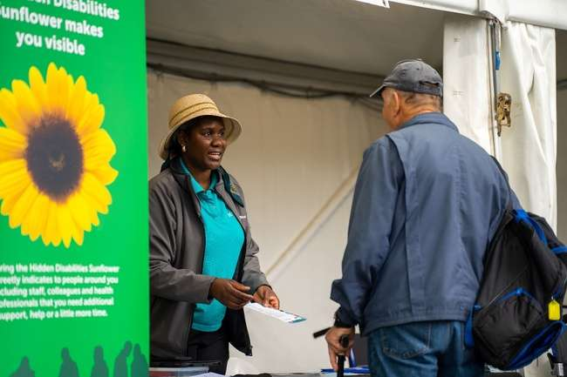

If I need help, I can talk to Event Staff. They are wearing Moomba Team uniform.

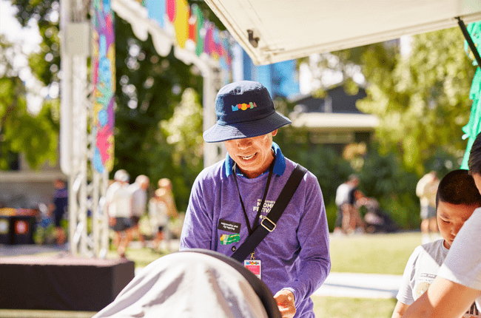

And Sunflower Badges

